ME 365: Systems and Measurements (with Lab)

(Report Title)

Lab report 1

Student Name: | ID:

Instructor: Dr. XXXXXXXX
Date: XX/XX/2020

Section: XX

Fall2020

Abstract:

Strain gauge are important tools in so many applications in today's world. It is a sensor whose resistance varies upon application of applied force. It converts physical quantity in electrical quantity. Strain gauge resistance depends on conductor geometry. When it is stretched it becomes thin and when it is compressed it becomes thick. So, the resistance changes. Resistance of a conductor depends on its length and cross section area. The change in shape and size of a resistance alters its length and area which effects resistance because resistance depends on both length and area. Gauge factor is the sensitivity factor or coefficient of strain gauges. Every material has different gauge factor. The Wheatstone bridge is used to measure the strain. The Wheatstone bridge is the electrical equivalent of two parallel voltage divider circuits with R1 and R2 as one of them and R3 and R4 as the other one. So for strain measurements we replace one resistor with strain gauge now any small change in it will be reflected in output voltage that can be measured. Mostly they are not affected by temperature changes. If they get than that can be corrected with thermistor. They have simple operating principle and easy maintenance. They are used in aerospace, strain monitoring, torque and power measurements in rotating equipment’s. They are used for the measurements of deformity in the structure to monitor them

Contents

1. Introduction (one page): 4
2. Literature Review (one page): 6
References 8

Introduction :

Strain Gauges are an important geotechnical tools that measure strain in underground cavities, tunnels, buildings, concrete, masonry dams, bridges, embedment in soil/concrete. A Strain gauge is a sensor whose resistance varies with applied force; it converts force, pressure, tension, weight, etc., into a change in electrical resistance which can then be measured. When external forces are applied to a stationary object, stress and strain are the result. As the object is deformed, the foil is deformed, causing its electrical resistance to change. This resistance change, usually measured using a Wheatstone bridge, is related to the strain by the quantity known as the gauge factor. Most strain gauges are smaller than a postage stamp, and they look something like this:
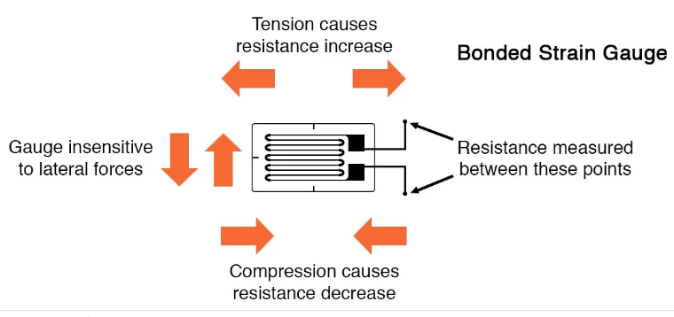
Figure: 1. Structure of Strain Gauge
A strain gauge works on the principle of electrical conductance and its dependence on the conductor’s geometry. Whenever a conductor is stretched within the limits of its elasticity, it doesn’t break but, gets narrower and longer. Similarly, when it is compressed, it gets shorter and broader, ultimately changing its resistance. The change in the resistance can be calculated with the help of a different interfacing such as Wheatstone bridge. A Wheatstone bridge is a network of four resistors with an excitation voltage, Vex that is applied across the bridge. The Wheatstone bridge is the electrical equivalent of two parallel voltage divider circuits with R1 and R2 as one of them and R3and R4as the other one. The output of the Wheatstone circuit is given by: Vo = [(R3/R3+R4) — (R2/R1+2)] * Vex. Another Type of interfacing is quarter-bridge. There are two more arrangements half-bridge and full-bridge configurations which give greater sensitivity over the quarter-bridge circuit. Still the quarter-bridge circuit is widely used in strain measurement systems.
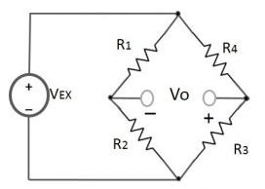
Figure 1.2: Wheatstone-bridge
We know, resistance is directly dependent on the length and the cross-sectional area of the conductor given by: R= L/A. Where, R = Resistance, L = Length and A = Cross-Sectional Area. The change in the shape and size of the conductor also alters its length and the cross-sectional area which eventually affects its resistance. Suppose L1 is the original length of wire and L2 is the new length after an external force is applied on it, the strain (ε) is given by the formula: ε = (L2-L1)/L1.
Interfacing Circuits:
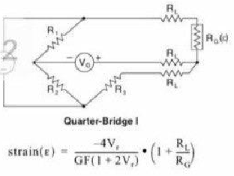 | 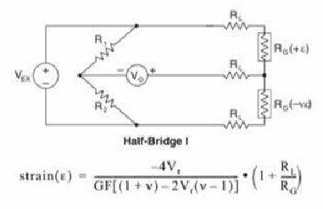 | 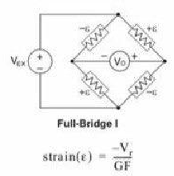
FIigure 1.3: Quarter Bridge Circuit | FIigure 1.4: Half Bridge Circuit | FIigure 1.5: Full Bridge Circuit

Strain gauges are extensively used in the field of geotechnical monitoring to keep a constant check on structures, dams, tunnels, and buildings so that the mishaps can be avoided well on time. The applications of strain gauges include Aerospace, Cable Bridges, and Rail Monitoring. Aircraft component testing is one area of application, tiny strain-gauge strips glued to structural members, linkages, and any other critical component of an airframe to measure stress. A strain gauge depends on the electrical resistivity of any conductor. The resistance in any conducting device is dependent on its length as well as the cross-section area.

Literature Review :

Strain gauge is a sensor whose resistance differs with the applied force which converts several physical quantities like: force, pressure, tension, and weight into an electrical signal that is used to measure the strain of an object. Nowadays, there are countless sorts to measure the deformation of an object under the action of force which is called “Strain” such as: Extension meter (Extensiometer), Photoelectric gauges, Metallic Wire-type strain gauges, Semiconductor strain gauges, and Thin-film Strain Gauges. As there are numerous types of strain gauges’ sensors, our group illustrated few of them and demonstrated on their applications.
2.1 Extension Meter Strain Gauge
For this type of strain gauges its function is measuring the variation in length and compare it with the original length of the object, on the other hand, mechanical strain gauges’ offer definite restrictions such as low resolution, and they are hard to use due to their large size. In addition, this kind of strain gauges is very rough and intensive to vibrations. There are some models of extension meter for example: 3542L which is designed to test various materials including metals, plastic, composites, and ceramic, Epsilon’s model 3543 is essential for applications that require extensive gauge lengths and superior measuring ranges (Long Gauge Length Axial Extensometers, nd).

Figure 2.1: Epsilon's Model 3543, (Long Gauge Length Axial Extensometers, nd).
2.2 Semiconductor Strain Gauge
Semiconductor strain gauges were produced for the utilization in car industry. Some key highlights of Semiconductors measurements: different than other strain gauges, semiconductor strain gauges depend on the piezo resistive impacts of silicon. The Semiconductor bonded strain gage is a wafer with the opposition factor diffused into a substrate of silicon, measures the variation in resistance and stress, and its cost is low because of its small size (Types of Strain Gauges, nd).
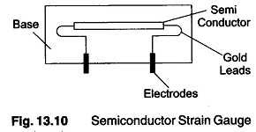
Figure 2.2: Semiconductor Strain Gauge, (Strain Gauge Transducer Types | Rossette gauge | Hysteresis, 2018).
2.3 Photoelectric Strain Gauge
As for this type of strain gauges, basically it uses a light beam or sun beam, two accurate gratings, and a photocell indicator to produce an electrical current in direct proportionate to the strain. Even though its size which is too tiny (1/16 inch), its usage proved to be highly expensive (Types of Strain Gauges, nd).
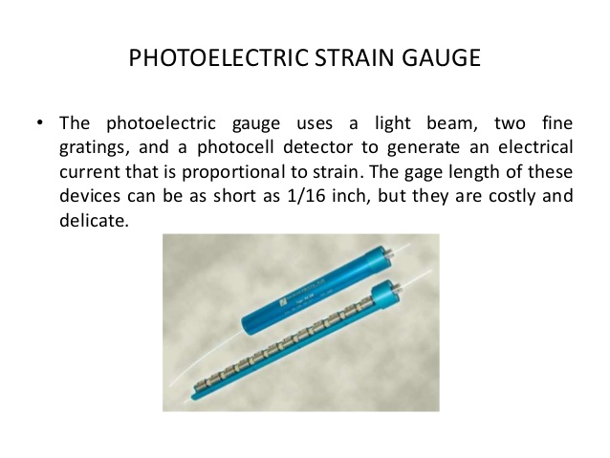
Figure 2.3: Photoelectric Strain Gauge, (Strain gauge, 2013).

2.4 Metallic Wire Strain Gauge
For this type strain gauges, it is built of various wire connections with almost 0.0001 in thickness, attached right on the strained surface through a thin layer of epoxy resin. Whenever, the Metallic Wire strain gauge experiences a change in its length due to an external force (load), this alteration of its length is transferred to the resistor that will result in measuring the corresponding strain in terms of the electrical resistance of the foil wire (Types of Strain Gauges, nd). The gauge factor for almost all types of strain gauges is measured by the following formula: $GF=\frac{∆R/R}{∆I/I}$
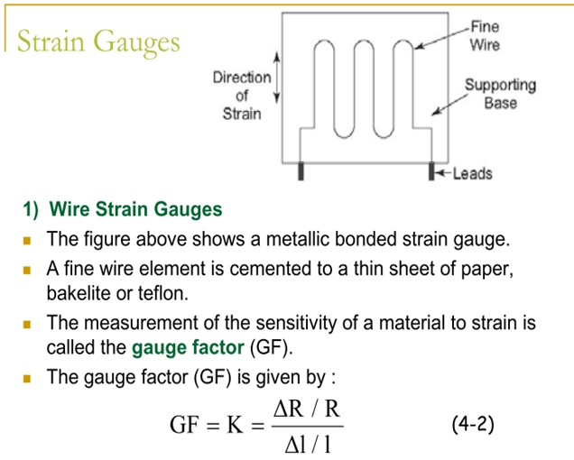
Figure 2.4: Metallic Wire Strain Gauge, (Electronics Measurement III Semester Electronics Engineering, nd).
2.5 Thin-Film Strain Gauge
It is an advanced strain gauge that is created by the deposition of an electrical insulation, regularly a ceramic on the stressed metallic surface, and placing the strain gauge on the insulation layer.
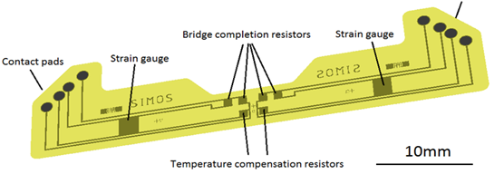
Figure 2.5: Thin-Film Strain Gauge, (Thin-Film Sensor, 2014)

References

[1] All about circuits, "Strain Gauges", Chapter-9 Electrical Instrumentation Signals, Boise, November 10,2017
[2] Encardio Rite, "Strain Gauge”, Strain Gauge: Principle, Types, Features and Applications, united states, July 3, 2019

